1. 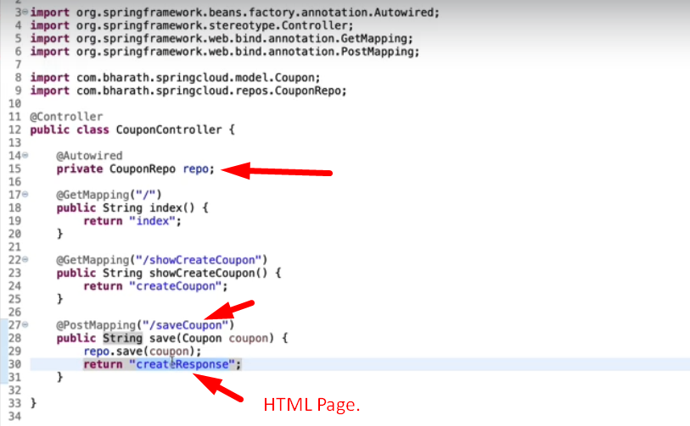
2. Returning from the above controller when coupon is saved successfully.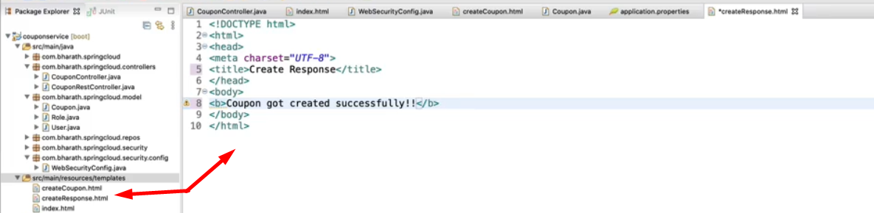
3. 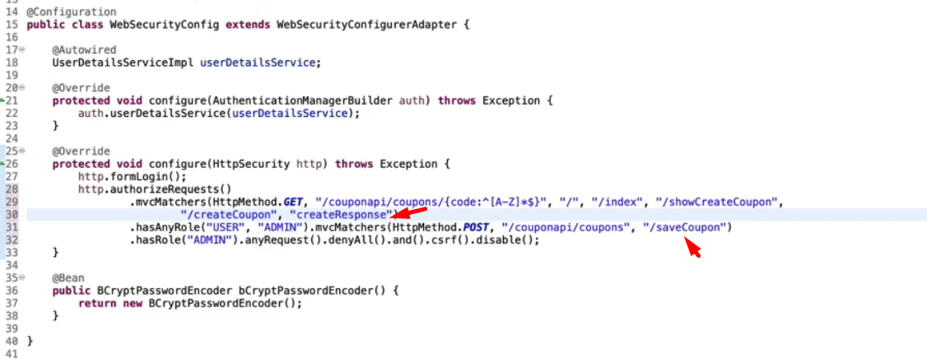
4. 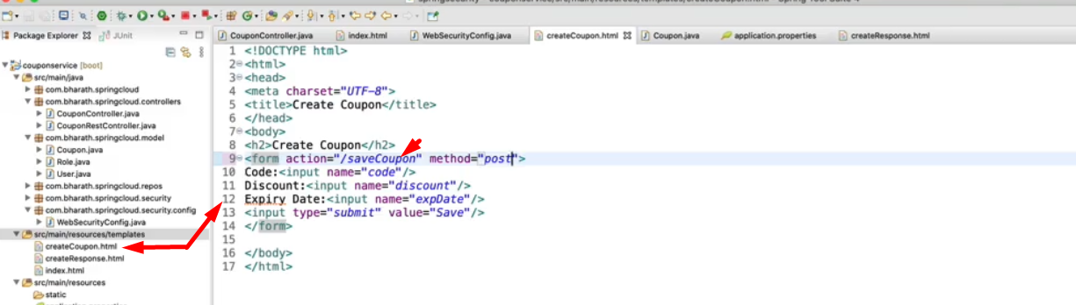
5. 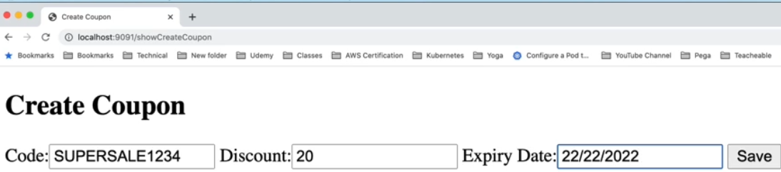
6. 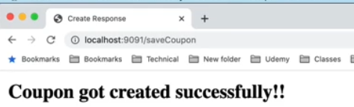
7. 